How to Navigate Between Bundles
A user can navigate between available bundles while uploading, monitoring the progress, or reviewing uploaded exhibits. Depending on the courts approach, the selection of bundles may vary and can include specific hearing, party, and/or shared bundles (view only access to all exhibits uploaded by all parties). Available bundles may also include auto generated bundles that are created when an exhibit is stamped and will be titled as Admitted, Admitted for Appeals Purposes, Offered but Denied, or Shown to Jury
While accessing a specific case, a user may switch between available bundles on the following screens and by default, the application will display the last bundle the user interacted with.
- Update Case > Sections Tab: Primarily accessed to upload or manage exhibits
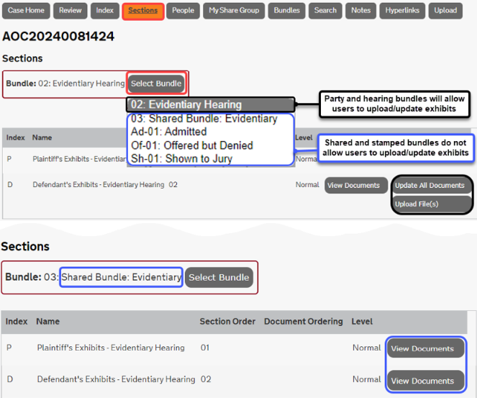

- Update Case > Index Tab : Primarily accessed to view the status of exhibits that have been uploaded or are processing
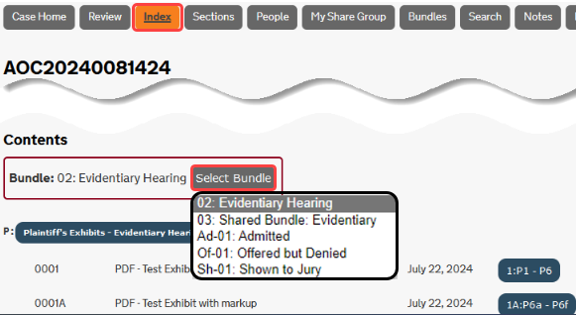
- Review Evidence > Review Tab: Primarily accessed in the courtroom to view, interact, and/or display uploaded exhibits
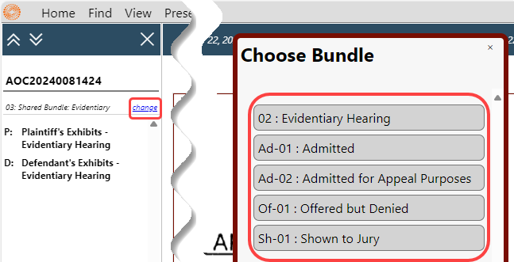
Please Note: Each court may require parties to access a specific bundle during courtroom proceedings, such as the shared bundle or specific hearing bundle.

