Automation Table Update Directions
HB2652: USED CATALYTIC CONVERTERS; SALES; ACQUISITIONS

Charge Information:
Action | Violation | Start Date | End Date | Abbrev. Description | Class | Case  Category | Case  Type
Off (*clean-up) | 44-1644B | 8/21/1998 | 5/8/2022 | SCRAP METAL DEALER RPT RQMTS | M1 | R44 | CR
Off (*clean-up) | 44-1644D | 8/21/1998 | 5/8/2022 | SCRAP METAL DEALER REPORT VIOL | M1 | R44 | CR
Add | 13-3728C | 5/9/2022 | 12/30/2099 | FAIL REPT PURCH CATLYTIC CNV | M1 | R27 | CR
Add | 44-1644B | 5/9/2022 | 12/30/2099 | SCRP MTL DLR CATYLTC CNV VIO | M1 | R44 | CR
*Clean-up Note: If your case management system does not have violation 44-1644B and 44-1644D in your tables previously then proceed to adding the new violations only.

Charge Screen
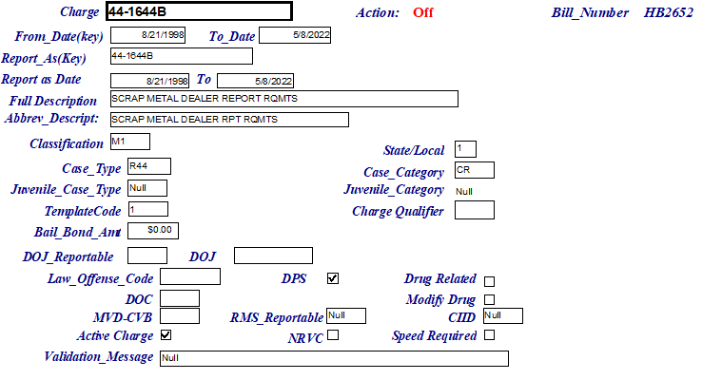

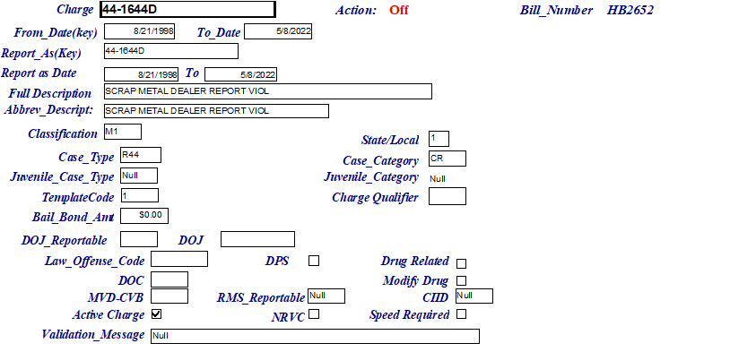

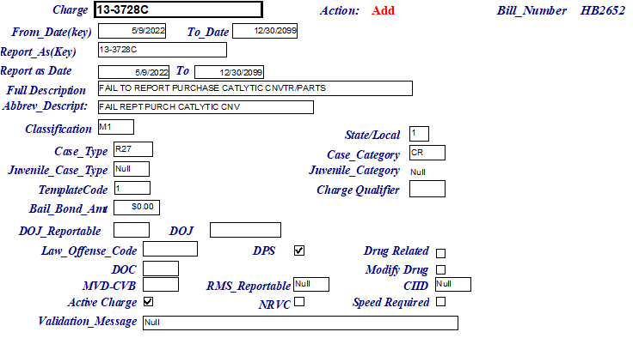

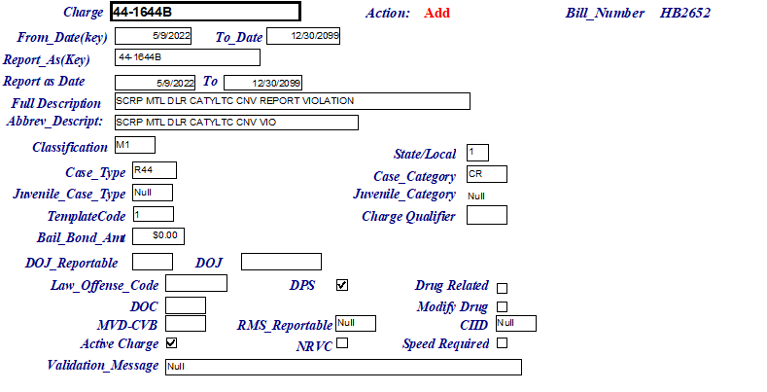

Penalty Schedule- Note: standard base fine and surcharges apply.
