Automation Update Directions
SB1294 (CH.432) Sentencing records; sealing arrest; liability
Delayed Effective Date 1/1/2023

General Automation Updates
Automation updates pursuant to SB1294 (CH.432) Sentencing records; sealing arrest; liability and rule petition R-22-0028 Petition to Amend Criminal Rule 26.11 and Adopt Rule (azcourts.gov). Tables for courts maintained by the Administrative Office of the Courts will be updated to reflect the changes. All courts can reference the detailed automation directions below, which include the following:
- Updated and New Forms
- New Event Codes
- New Case Type
- New Case Sub Type
- New Appearance Reason
- *Seal Case Functionality

New and Updated Forms
Type | Form | Jurisdiction
Update | Form 23(A). NOTICE OF RIGHTS AFTER SENTENCING IN THE SUPERIOR COURT (NON-CAPITAL) | GJ ONLY
New | PETITION INFORMATION SHEET | GJ, LJ
New | PETITION TO SEAL CRIMINAL CASE RECORDS (A.R.S. § 13-911) | GJ, LJ
*New | REQUEST TO OBTAIN CRIMINAL HISTORY REPORT FROM DPS | GJ, LJ
New | ORDER REGARDING PETITION TO SEAL CRIMINAL CASE RECORDS A.R.S. §13-911 | GJ, LJ
*Note: New form created by DPS. Pdf and word version links provided with directions.

New Event Codes
Code | Description | DW Event Code | Jurisdiction | Display Public Access
SR1 | PETITION TO SEAL RECORDS ARS §13-911 | 13786 | GJ, LJ | Y
SR2 | REQUEST CRIMINAL HISTORY REPORT-DPS | 13787 | GJ, LJ | Y
SR3 | CRIMINAL HISTORY REPORT RETURNED-DPS | 13788 | GJ, LJ | Y
SR4 | NOTICE SEAL RECORDS - INSUFFICIENT INFO | 13789 | GJ, LJ | Y
SR5 | NOTICE SEAL RECORDS - SUFFICIENT INFO | 13790 | GJ, LJ | Y
SR6 | AMENDED PETITION TO SEAL RECORDS | 13791 | GJ, LJ | Y
SR7 | RESPONSE TO PETITION SEAL RECORDS | 13792 | GJ, LJ | Y
SR8 | REPLY TO SEAL TO PETITION SEAL RECORDS | 13793 | GJ, LJ | Y
SR9 | REQUEST FOR HEARING TO SEAL RECORDS | 13794 | GJ, LJ | Y
SR10 | ORDER SEAL RECORDS- GRANTED ARS §13-911 | 13795 | GJ, LJ | N
SR11 | ORDER SEAL RECORDS - DENIED ARS §13-911 | 13796 | GJ, LJ | Y
SR12 | ORDER SEAL RECORDS - DISMISSED ARS §13-911 | 13797 | GJ, LJ | Y
SR13 | MINUTE ENTRY: SEAL RECORDS HEARING | 13798 | GJ ONLY | Y

New Appearance Reason
Code | Calendar Appearance Reason | Jurisdiction
SRH | SEAL RECORDS HEARING | GJ, LJ

New Case Type & Sub Case Type
The following Case Type and Sub Case Type were created to capture petitions for seal records (per A.R.S. §13-911) when the court has no available criminal case because the case has been purged or the petition is to seal the records of an arrest record only. As a result, a civil case will need to be created. Below is the general overview and an example of the fields selected for case creation.

Code | Case Type | Jurisdiction
SRC | SEAL RECORDS | GJ, LJ

Code | Case Sub Type | Jurisdiction
SRA | 13-911 | GJ, LJ

Civil Case Creation Example and Screenshot
Court Type: Civil
Case Category: Civil
Case Type: Seal Records
Case Sub Type: 13-911
Filing Type: *Varies by Jurisdiction (LJ= New Case Filing, GJ= Type of Filer)
Commenced by: Petition

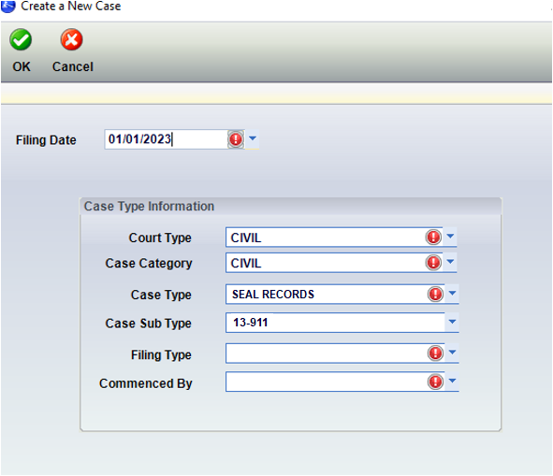

*Seal Case Functionality
IMPORTANT: All courts should have functionality to seal and remove a case from public access at the case level. If functionality already exists, then this will be training only unless additional automation is determined.

Sealing a Criminal Case- AJACS Example
AJACS currently has automation that will seal the case and remove it from public access.
The screenshot below provides an example of case functionality on how to seal a criminal case after a petition is granted. In this scenario, an order to seal records is granted and all events have been entered on the case. The user’s last step would be to select the “Seal Case” check box which also checks the “Remove from Public Access” check boxes.
